**NAME: JOSEPH OLOWE**

**TITLE: CASE STUDY FOR RARE EAT’S E-COMMERCE BUSINESS.**

**QUESTION 1**: Describe the key components that should be included in a process map for Rare Eat’s order fulfilment.

**ANSWER:**

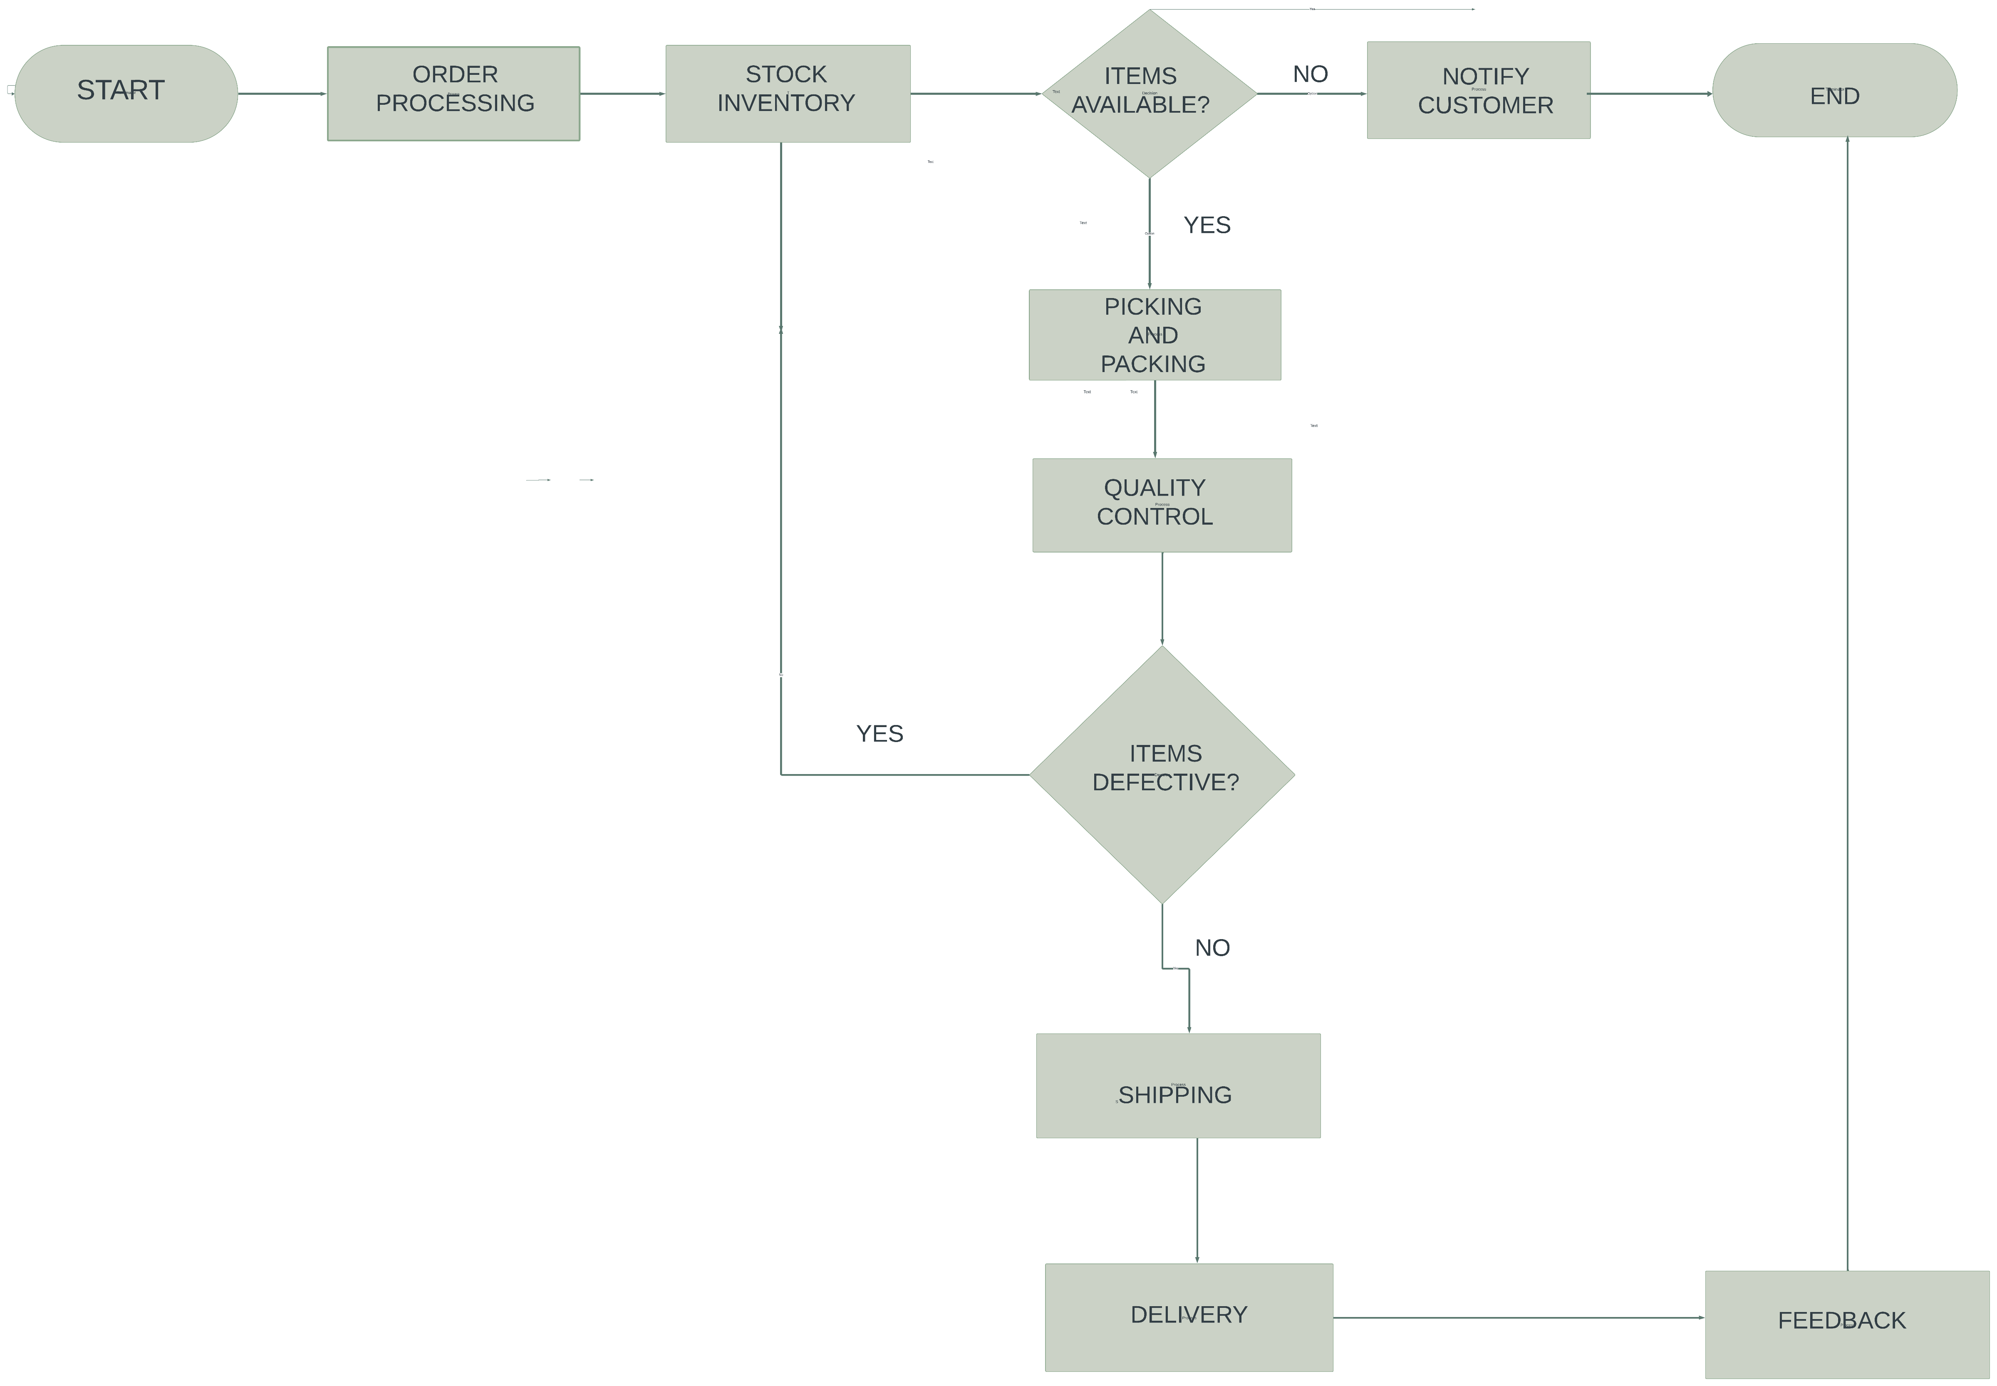

1. ORDER PROCESSING: This involves verifying the order details such as the item(s) ordered, the quantity, the delivery address, and any special or useful information.
2. STOCK INVENTORY: This step involves checking the inventory to ensure that all the items in the customer order are available. If any item is out of stock, this process may include notifying the customer.
3. PICKING AND PACKING: Once the inventory has been confirmed, the items are then picked from the warehouse and packed safely for shipping.
4. QUALITY CONTROL: This involves thorough inspection of the packed items to ensure that they meet the quality standards and are not damaged or defective.
5. SHIPPING: This step involves first generating shipping labels with the correct delivery address and any other necessary information for shipping carriers. The package is then handed over to the shipping carriers for delivery to the customer. This may also involve different shipping methods depending on the customer’s location or preferences.
6. DELIVERY: Here, the shipment is being tracked to ensure that it reaches the customer on time and safely. This step involves communicating delivery updates to the customer or providing an avenue where the customer can track their own item themselves.
7. FEEDBACK: After the item has been delivered to the customer, there is need to get feedback from them about their order and delivery experience.

**QUESTION 2:** Explain how process mapping can help Rare Eat identify and resolve bottlenecks in their subscription management workflow.

**ANSWER:**

Process mapping is an important first step in finding bottlenecks because it gives a clear picture of how things work visually. It helps you see the entire workflow, spot places where things might get stuck, and figure out which parts are slowing things down or not working efficiently. With a detailed map of the process, one can start analysing and fixing any bottlenecks in a structured way.

In the case of Rare Eat, process mapping can help them identify and resolve bottlenecks in their subscription management flow by:

1. Identifying Bottlenecks: With process mapping, Rare Eat can pinpoint exact steps or stages in the subscription management process where things are slowing down. These slowdowns, called bottlenecks, might happen because there aren't enough resources, the processes aren't working well, or the systems aren't up to par. Once Rare Eat knows where these bottlenecks are, they can concentrate on fixing them to make the workflow smoother and more efficient.
2. Root Cause Analysis: Process mapping helps Rare Eat dig into the root causes of bottlenecks. They can look at things like how resources are assigned, how complicated the processes are, and what limitations the systems have. By figuring out what's really causing the bottlenecks, they can come up with specific solutions to fix them.
3. Continuous Improvement: Process mapping helps Rare Eat keep getting better at managing subscriptions. They can regularly look at the process map to find any new problems that pop up and fix them right away. This ongoing effort makes sure that their system keeps improving and running more smoothly over time.
4. Measuring Cycle Time: With process mapping, Rare Eat can see how long each step in managing subscriptions takes. By looking at these times, they can figure out which steps are taking longer than they should and figure out why. This helps them find ways to speed things up and get rid of delays.
5. Visual Representation: Process mapping creates a picture of how Rare Eat handles subscriptions, from beginning to end. This visual map helps them spot where things slow down or get stuck more easily.
6. Making Things Better: After finding and understanding bottlenecks, process mapping helps Rare Eat find ways to make things run smoother. They might simplify how things are done, change how resources are used, automate tasks, or upgrade systems. These changes help make the workflow more efficient and cut down on bottlenecks.
7. Spotting Transitions: When Rare Eat maps out each step in managing subscriptions, they can see where tasks move from one person or department to another. These handoffs could cause problems if information or tasks don't get passed along smoothly or if there are delays.

**QUESTION 3**: Provide an example of a swimlane diagram that could be used to represent interactions between different roles or departments within Rare Eat's e-commerce operations.

**ANSWER:**

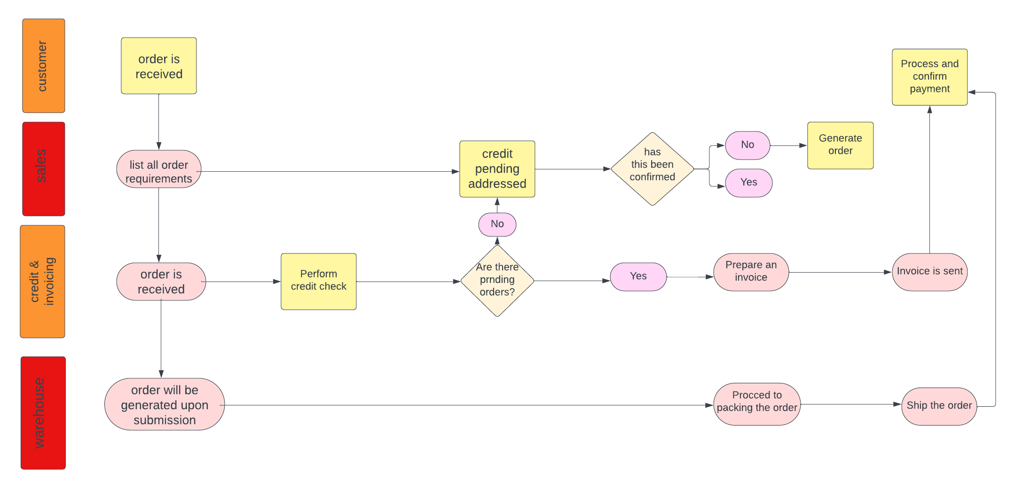

**An interaction between key roles of Rare Eat for a customer’s order.**

**QUESTION 4:** Describe the importance of documenting exception-handling processes within Rare Eat's e-commerce workflow, such as how they handle out-of-stock items.

**ANSWER:**

Documenting how Rare Eat handles exceptions in their e-commerce workflow ensures that things are consistent, efficient, and satisfying for customers. It helps manage risks and makes it easier to train new employees while also allowing for ongoing improvements. The importance of documenting this process is further highlighted below:

1. Consistency: When Rare Eat documents how they handle exceptions, it means that everyone follows the same steps, no matter which team or person is involved. This consistency reduces confusion and ensures that customers always get the same level of service, no matter who is taking care of their order.
2. Continuous Improvement: When Rare Eat writes down their processes for handling exceptions, it lets them regularly check and improve how they deal with these situations. They can look at past exceptions, see what worked well and what didn't, and then update their processes to make things run even better. This ongoing effort helps them keep getting more efficient and effective over time.
3. Risk Management: Writing down how Rare Eat handles exceptions helps them deal with unexpected problems, like items being out of stock. By laying out clear steps for handling these situations, Rare Eat can reduce the negative effects they have on their business and reputation.
4. Customer Satisfaction: When Rare Eat clearly writes down how they handle exceptions, it helps them give customers a better experience. Customers like knowing what's going on and getting updates quickly, especially if there's an issue with their order, like an item being out of stock. Having clear processes means Rare Eat can communicate with customers fast and offer solutions like backordering or refunds, making customers happier.
5. Training and Onboarding: When Rare Eat writes down how they handle exceptions, it helps train new employees. These documents give clear instructions on what to do in different situations, making it easier for new hires to learn how to manage problems in the e-commerce workflow quickly.
6. Efficiency: When Rare Eat writes down how they handle exceptions, it makes things run smoother and faster. Having clear processes means employees can quickly look up what to do when something unexpected happens, so they spend less time figuring things out and more time solving problems efficiently.

**QUESTION 5**: Explain the role of feedback loops in continuous process improvement for Rare Eat's e-commerce operations and how they can be represented in workflow documentation.

**ANSWER:**

Feedback loops are essential for continuously improving Rare Eat's e-commerce operations. They help gather insights, assess how well things are working, and drive ongoing improvements. Here's how they help and how they can be shown in workflow documentation:

1. Putting Customers First: Feedback loops ensure Rare Eat stays focused on its customers by listening to their feedback and using it to make continuous improvements. By addressing customer concerns and suggestions, Rare Eat builds loyalty, improves the overall customer experience, and ultimately drives business growth.
2. Gathering Information and Assessing: Feedback loops gather data from various sources such as customer feedback, employee suggestions, performance metrics, and market trends. This information helps Rare Eat understand how their processes are functioning and where they need to make improvements.
3. Making Things Better Step by Step: Rare Eat uses feedback loops to continuously improve their operations. They make small adjustments to processes, policies, systems, and customer interactions based on feedback, gradually refining and optimizing their e-commerce operations.
4. Spotting Ways to Improve: Rare Eat analyzes feedback to find areas where they can make things better. This could mean finding ways to make the website easier to use or making the process of processing orders faster and smoother.

Furthermore, in workflow documentation, it's important to include ways to gather feedback at different points in the e-commerce operations. This ensures that feedback is collected regularly, analyzed, and used to make ongoing improvements. By including feedback loops in their workflow documentation, Rare Eat can use feedback systematically to improve processes continuously, increase operational efficiency, and provide exceptional customer experiences in their e-commerce operations. Here's how feedback loops can be shown:

1. Monitoring and Reviewing: Outline the steps for keeping an eye on the changes that have been made and reviewing how well feedback loops are working. Specify which metrics will be used to measure the success of improvements and set up regular check-ins to evaluate how well feedback loops are performing and make any necessary adjustments.
2. Turning Feedback into Action: Describe the steps for turning feedback into practical insights and making improvements. Document how feedback is used to find ways to enhance processes, decide which improvements to prioritize, and effectively implement changes.
3. Analyzing and Evaluating Feedback: Outline the steps for analyzing and evaluating the feedback that's received. Specify who's in charge of reviewing the feedback, how it's sorted and ranked, and how often the analysis is done.
4. Points for Collecting Feedback: Identify particular stages in the workflow where feedback can be gathered, like after fulfilling orders, during customer service interactions, or through post-purchase surveys. Document the ways and platforms used to collect feedback, such as online reviews, customer surveys, or employee feedback channels.

**NOTE: ALL DIAGRAMS WERE MADE WITH LUCIDCHART.**